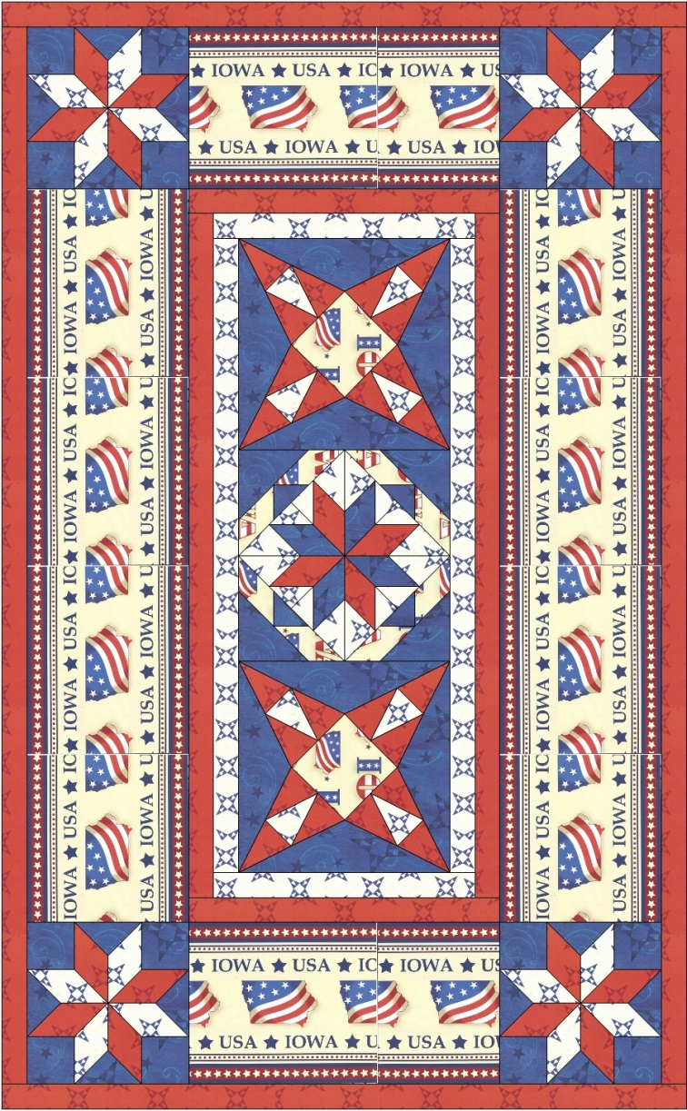

Quilt Size 27 ½” x 44 ½”

|  |  |
| --- | --- |
| Fabric Requirements |  |

# SRK – 15449-202

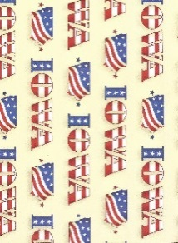(Red, White, and Blue Iowa Flags) 3/8 Yards

# SRK – 15450-91

(Red Tone on Tone Iowa Star Print) 5/8 Yards

SRK – 15448-202

(Iowa Border Print with Tone on Tone Blue Stars) 1 1/4 Yards

# SRK – 15450-265

# (Blue & White Iowa Star Print) 3/8 Yard

# 

**Making the Iowa Star 8 1/2" Block**

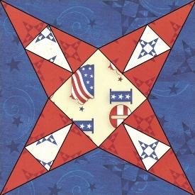

**Sewing Instructions:**

**Step 1:** Cut out 12 triangles from the “C” Iowa Star Template using the Red Tone on Tone Iowa Star Print fabric. Cut out 4 triangles from the “C” Iowa Start template from the Blue & White Star print fabric.

**Step 2:** Sew the unit together referring to the diagram below. Make 4 units. Shorten your stitch length on your sewing machine to make the removal of the paper easier!

   

**Step 3:**  Cut a 3 ½” x 3 ½” square or use the Iowa Start “B” Template to cut this square.



**Step 4:**  Sew the units made in **Step 2** to each of the 4 side of the 3 ½” x 3 ½” square you cut in **Step 3** using a 1/4" seam allowance.

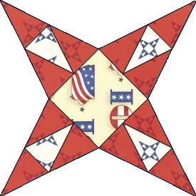

**Step 5:**  Cut 4 side triangles from the Iowa Star Template “A”.



**Step 6:**  Sew triangles units to star unit made in **Step 4** using a 1/4" seam allowance. *Tip: Sew on the triangle units starting from center of triangle to edge of block.



|  |
| --- |
| Your block should measure 9" on all sides.  It will measure 8 1/2" finished size when it is sewn into a quilt. |

You'll need to make the block 2 times. Repeat **Steps 1** through **6**.

**Making the Iowa Evening Star 8 1/2" Block**

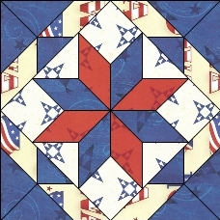

**Sewing Instructions:**

**Step 1:** Print out 4 copies of each of the Iowa Evening Star paper-piecing patterns.

**Step 2:** Following the numbers printed on the Iowa Evening Star pattern and the fabric diagram below, paper-piece four identical units using the blue fabric and four identical units using the red fabric.  Shorten your stitch length on your sewing machine to make the removal of the paper easier!

**       **

**Step 3:** Sew a blue and red unit together using a 1/4” seam allowance. Repeat 4 times.

   

**Step 4:** Sew 2 units together using a 1/4” seam allowance. Repeat 2 times.

 ↔ 

 ↔ 

**Step 5:** Sew these units together using a 1/4” seam allowance.



**↕ ↕**



Your block should look like this. 

**Step 6:** Following the numbers printed on the Iowa Evening Star paper piecing pattern and the fabric diagram below, paper-piece four identical units.

   

**Step 7:** Sew the corner units made in **Step 6** to the eight pointed star block using a 1/4” seam allowance.



**↕ ↕**

 ↔  ↔ 

**↕ ↕**



You finished block now looks like this. 

|  |
| --- |
| Your block should measure 9" on all sides.  It will measure 8 1/2" finished size when it is sewn into a quilt. |

**Making the Eight Pointed Corner Star 6 ½” Block**



**Sewing Instructions:**

**Step 1:** Print out four copies of each of the Eight-Pointed Star paper-piecing patterns.

**Step 2:** Following the numbers printed on the pattern and the fabric diagram below, paper-piece four identical units using the blue fabric and four identical units using the red fabric.  Shorten your stitch length on your sewing machine to make the removal of the paper easier!

**   **

**   **

**Step 3:** Sew a blue and red unit together using a 1/4” seam allowance. Repeat 4 times.

   

**Step 4:** Sew 2 units together using a 1/4” seam allowance. Repeat 2 times.

 ↔ 

 ↔ 

**Step 5:** Sew these units together using a 1/4” seam allowance.



**↕ ↕**



Your block should look like this. 

You'll need to make the block 4 times. Repeat **Steps 1** through **5**.

**Assembly Instructions**

**Step 1:** Sew a Iowa Star blocks and the Evening Star blocks together in rows and then sew rows together to make center section 1/4” seam allowance.

 ↔  ↔ 

|  |
| --- |
| The center should measure 26" on all sides.  It will measure 25 1/2” finished size when it is sewn into a quilt. |

# **Step 2:** Cut 2 – 26” x 1 ½” strips from the blue and white star fabric (SRK – 15450-265)

**Step 3:** Sew the 26” strip just cut to left and right sides of the center made in **Step 1** 1/4” seam allowance.

 ↔ 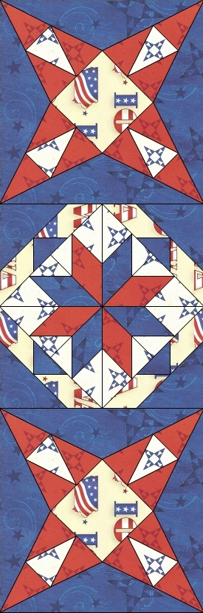 ↔

# **Step 4:** Cut 2 – 11” x 1 ½” strips from the blue and white star fabric (SRK – 15450-265)

**Step 5:** Sew the 11” strip just cut to top and bottom of the center made in **Step 1** using 1/4” seam allowance.



**↕ ↕** **↕**

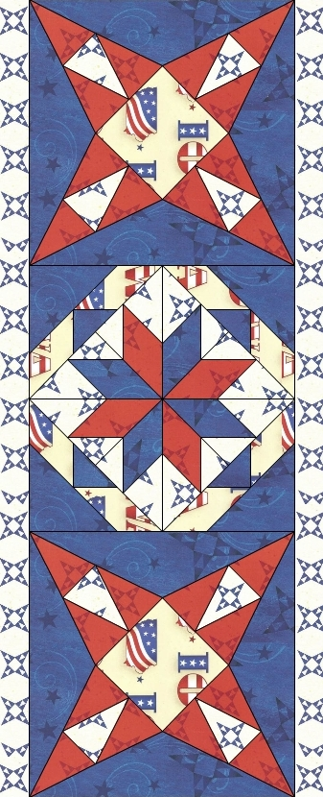

**↕ ↕** **↕**



# **Step 6:** Cut 2 – 28” x 1 ½” strips from the (Red Tone on Tone Iowa Star Print)

**Step 7:** Sew the 28” strip just cut to the left and right sides of the center made **Step 5** using a 1/4” seam allowance.

 ↔ 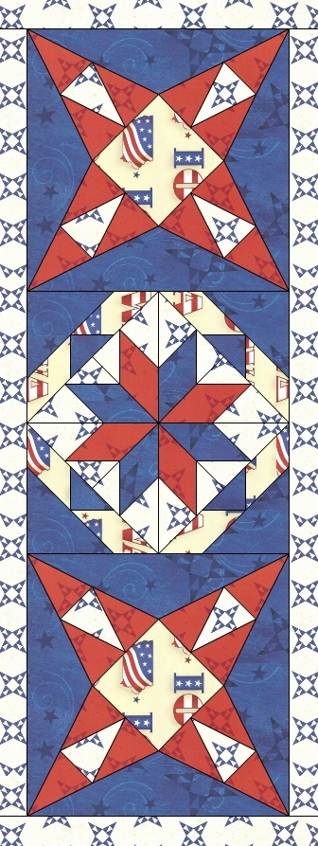 ↔ 

# **Step 8:** Cut 2 – 13” x 1 ½” strips from the (Red Tone on Tone Iowa Star Print)

**Step 9:** Sew the 13” strip just cut to the top and bottom of the center made **Step 7** using a 1/4” seam allowance.



**↕ ↕** **↕**

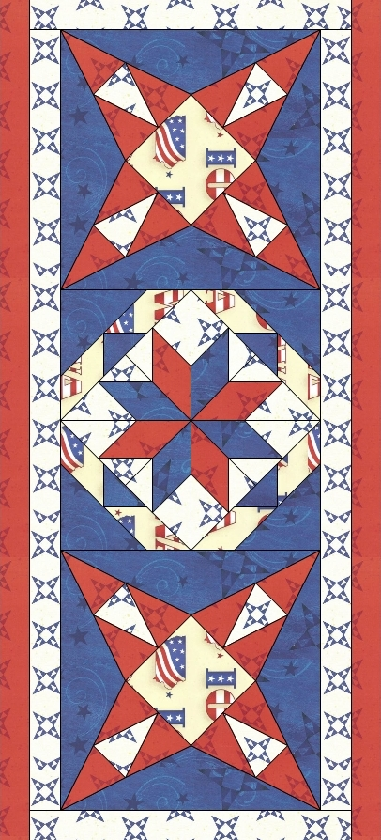

**↕ ↕** **↕**



# **Step 10:** Fussy cut 2 – 30” strips from the (Iowa Border Print with Tone on Tone Blue Stars). Fussy cut 2 – 13” strips from the (Iowa Border Print with Tone on Tone Blue Stars). The strip needs to cut from the blue outside strip to the blue outside strip of the border print.

# 

**Step 11:** Sew 2 of the 30” border strips just cut to the left and right sides of the center made **Step 9** using a 1/4” seam allowance.

 ↔ 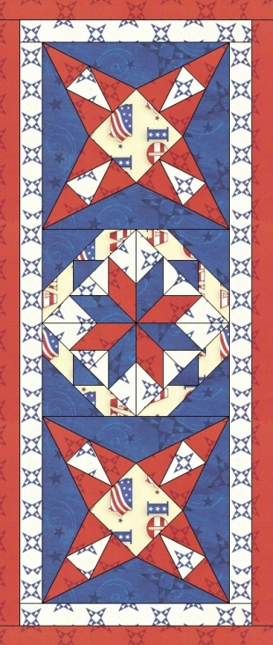 ↔ 

**Step 12:** Sew 2 the eight pointed star blocks to each end of the other two 13” border stripsusing a 1/4” seam allowance.

↔↔

↔↔

**Step 13:** Sew the units just made to the top and bottom using a 1/4” seam allowance.



**↕ ↕** **↕ ↕**

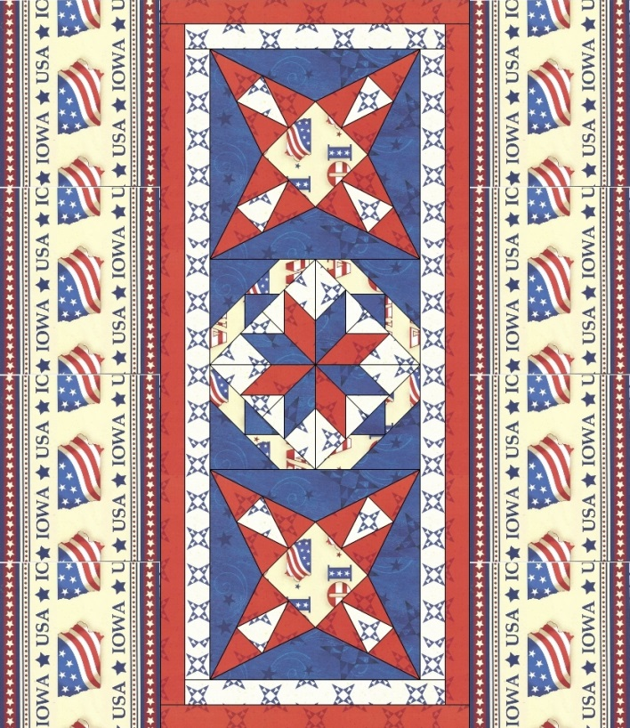

**↕ ↕** **↕ ↕**



**Step 14:** Measure the width of the top. Cut 2 - 1 ½” x (this measurement) strips using the Red Tone on Tone Iowa Star Print fabric. Attach strips to left and right sides using a 1/4” seam allowance.

**Step 15:** Measure the length of the top. Cut 2 - 1 ½” x (this measurement) strips using the Red Tone on Tone Iowa Star Print . Attach strips to top and bottom sides of the quilt using a 1/4” seam allowance.

**Step 16:** Layer your top with batting and backing and quilt as desired.

**Step 17:** Bind using your favorite binding technique.

*Congratulations!!!! Your Iowa Star Salute Table Runner is now ready to enjoy.*



